Fastapi connection with mysql

Database.py

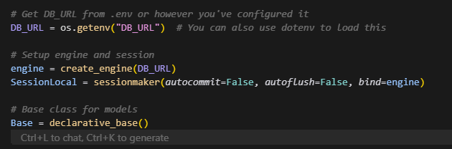

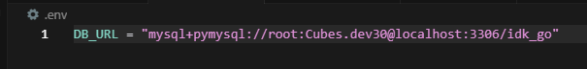

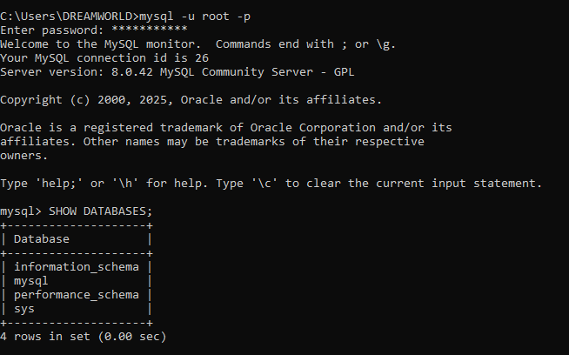



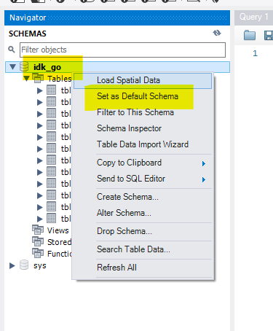

Set as default schema and you are good to go! All tables will get created automatically